**Assignment 8 Image analysis**

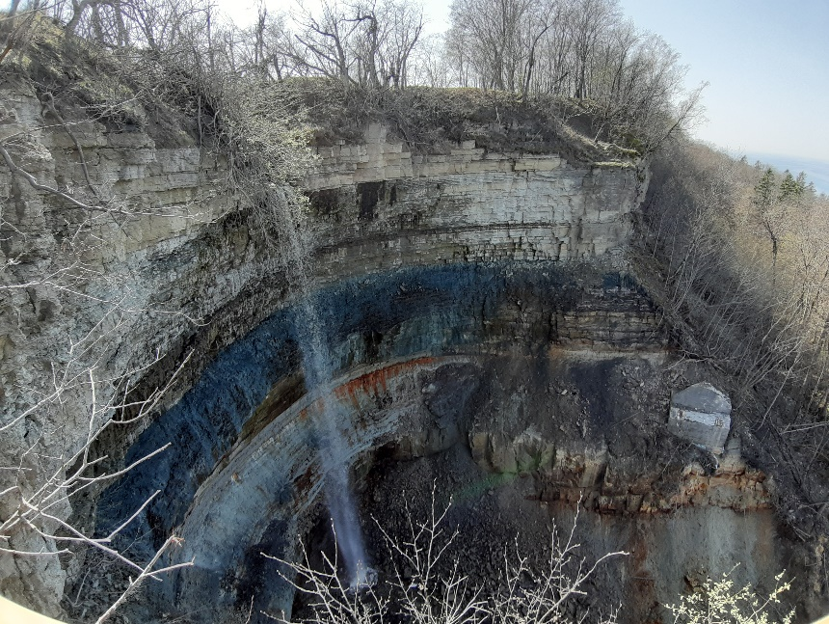**Angle:** The Angle was chosen natural, to capture all colorful rocks and to manage visible all the waterfall in the picture.

**Distance:** Main object which is captured is a waterfall and it was like pretty much impossible to get close capture, so I do shoot from long distance. And for sure I was standing on the hill when taken that picture, so there no possibility to get further with that good view because then there will be trees which spoils the view in it’s final look on camera.

**Composition:** Composition is very colorful because the photographed layers of rock create stunning view on this nature shoot. Without that colorful rocks the composition would look very gloomy. But it’s a calm view on waterfall which got photographed very focused on picture quality, because of that picture have very good quality and was taken by me in real life situation to capture my own nature picture.

**Depth of field:** Focus in the picture was very deep because it was important to take a picture with best detail possible and that shoot was like best of all which was taken. Some of them wasn’t with so good detail, so it was important to manage high detail picture and because of that there were about 10 photos taken.

**Lens type:** In this picture was using wide-angle lens to get better nature photo and get more detail in it. Picture was taken from the hill, so there was not an option to get further with same height position.

**Film stock:** Picture was taken slow to make stable with maximum possible quality. Like normal people which want to make great captures. Just stay calm and take shoot without unnecessary movements.

**Mobile frame:** Capture was taken Handheld and focused on the waterfall to get best focus at that object to save that point of view which is expected to get.

**Lighting:** It was very important to get good lighting in the capture because there was very sunny outside and it was about top of it. So the capture was focused on waterfall to get best possible lighting on that object and fully see the main waterfall and detail close to it.